Leetcode question
Power of Three - LeetCode
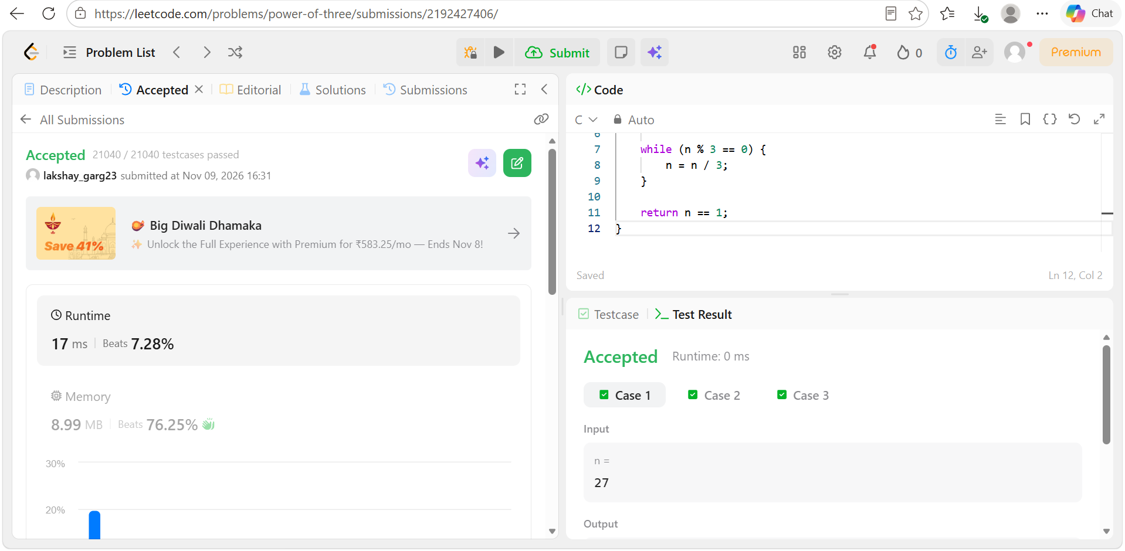
Code
#include <stdbool.h>

bool isPowerOfThree(int n) {
if (n <= 0)
return false;

while (n % 3 == 0) {
n = n / 3;
}

return n == 1;
}

